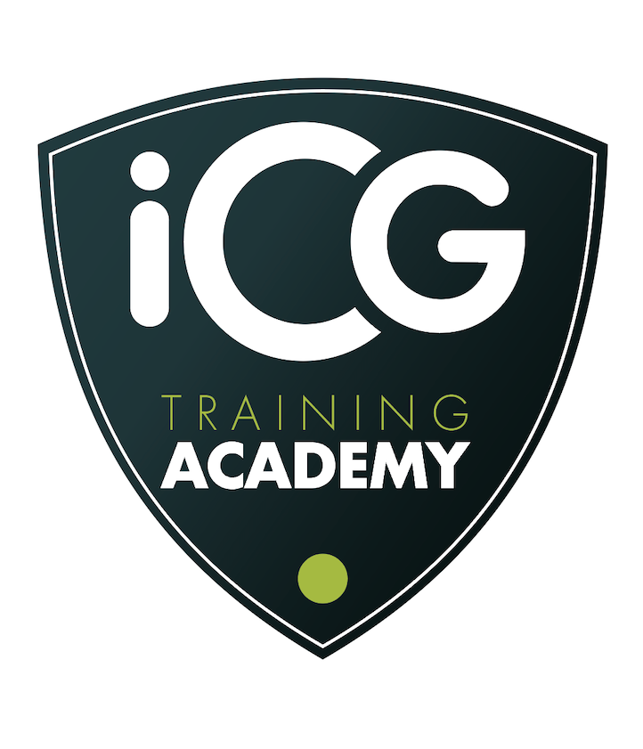

The Mike Padgham Bursary Award 2026/27
This year’s bursary is open to managers, team leaders and aspiring managers who work in organisations that are members of iCG.
Please complete this form and return to Debbie, at Businessmanager@independentcaregroup.co.uk no later than 4pm on 22 September 2026.

Section 1 – Contact Details

Name

Telephone Number

Email

Section 2 - Your employment

Current role

Time in this role

Employer

Employer’s address

Details of other relevant work or volunteering you have done
Section 3 - Your application

Please highlight which award you wish to be considered for by highlighting the relevant yes or no option. | Yes/  no | A funded place on the Management Development Programme for a Registered Manager, which is fully accredited and includes a year’s subscription to the Institute of Leadership.
 | Yes/  no | Introductory Management Training for aspiring managers who need to learn more and develop their skills.  (two awards are available for this training)
Use this space to tell us about your past training and your qualifications. | (400 words maximum)
Please tell us why you think you should be considered for this training bursary. | (400 words maximum)
Section 4 – Authorisation

Please confirm that your line manager and/or employer is aware of this application and has confirmed that they will permit you to attend the course
Name of line manager

Date of submission

NOTES
- The winner(s) cannot substitute the award and all the arrangements for training are commissioned by iCG Training Academy and provided by Care Ideals.
- All entries will be treated confidentially.
- Entries will be judged by the iCG Chief Executive and Care Ideals Managing Director and if a third view is required, the iCG Business Manager.
- Entries will not be returned.
- Awards will be announced at the iCG conference on 22 October 2026.

